“PROBLEM OF PRODUCTION REJECTION IN PIPE PLANT & BLOWN FILM LINE MACHINES’’

INDEX
CH  NO | TOPIC NO | TOPIC NAME | PAGE  NO
1 |  | Introduction of company profile & detail
2 |  | Introduction of machines
 |  | Pipe plant machines
 | 2.1 | Introduction of Extrusion
 | 2.1.1 | Definition Of Extrusion
 | 2.1.2 | Classification of Extrusion
 | 2.1.3 | Advantages and Disadvantages of Extrusion
 | 2.1.4 | Application
 | 2.1.5 | Types of Extrusion Machines
 | 2.2 | Pipe Extrusion Lines machines
 | 2.2.1 | Introduction
 | 2.2.2 | Types of Pipe Extrusion Lines Machines
 | 2.2.3 | Single Screw Pipe Extrusion Lines Machine
 | 2.2.4 | Twin Screw Extrusion Line Machine
 | 2.2.5 | Working of Extrusion Line Machine
 | 2.2.6 | Components of Extrusion Line Machine
 | 2.3 | Blown Film Lines Machines
 | 2.3.1 | Introduction
 | 2.3.2 | Types of Blown Film Lines Machines
 | 2.3.3 | Monolayer Blown Film Lines Machine
 | 2.3.4 | Three layer Blown Film Lines Machine
 | 2.3.5 | Five layer Blown Film Lines Machine
 | 2.3.6 | Working of Blown Film Lines Machine
 | 2.3.7 | Components of Blown Film Lines Machine
 | 2.4 | Blow Moulding Machine
 | 2.4.1 | Introduction
 | 2.4.2 | Technical Specifications of Blow Moulding Machine
 | 2.4.3 | Features of Blow Moulding Machine
 | 2.4.4 | Application of Blow Moulding Machine
 | 2.4.5 | Working of Blow Moulding Machine
 | 2.4.6 | Components of Blow Moulding Machine
3 |  | PROBLEM SUMMARY
 | 3.1 | Pipe Plant Machine
 | 3.2 | Blown Film Line Machine
4 |  | EXPECTED OUTCOME
 | 4.1 | Solution of pipe plant machine
 | 4.2 | Solution of blown film line machine

CHAPTER 1

INTRODUCTION OF COMPANY

PROFILE & DETAILS

technical collaborations

Windsor machines are the India’s largest plastic processing machinery manufacturing and exporting company.

Windsor machines have been manufacturing a complete range of plastic processing machinery for more than decades.
collaboration with R.H. Windsor of U.K.

In 1984 klockner works of Germany made the company a part of its worldwide operation and renamed it Klockner Windsor Ind. Ltd.

Then in 1994 Mr. Dilip G. Primal bought the company and the name was again changed to Windsor machines India Ltd

Windsor machines has three state of art plants in India at Than Ahmadabad and Chhatral employing over 1500 employees.

Staff welfare
The relationship between the company and employees is comparatively good. Staff member works with their full efficiency and try to give their maximum for the progress and welfare of the staff.
The company gives good canteen facility which runs on the contract basis. Company provides tea snacks lunch and dinner to the staff and workers at subsidized rate.
The company has setup water coolers with aqua guard in all the departments which provides cool and clean water to the staff.
Company gives good salary, yearly increment and bonus to the employees.
Company runs good credit society of the staff and workers jointly. This society also gives the loans to employees.

Company gives sweets and dress to the workers on diwali.
Company also organizes sports activities on dashera like cricket, volleyball long jump etc. between all departments and give prizes to the winners.
Company pays travel allowance and leave with pay to all staff member. It also pays the medical allowance to the worker.

The company celebrates the joy of each ones birthday by gift.

Various Departments of the company

Personal Department
Purchase Department
Sales Department
Marketing Department
R & D Department
EDC Department
Assembly Department
Machine and Die Department
Testing Department
Quality Department
Account & Finance Department
Maintenance Department
Store and Inspection department
Planning Department
Electrical Department

CHAPTER 2

DETAILS OF MACHINES & IT’S WORKING

2.1 Definition of extrusion
Extrusion is the process by which a block/billet of metal is reduced in cross section by forcing it to flow through a die orifice under high pressure.
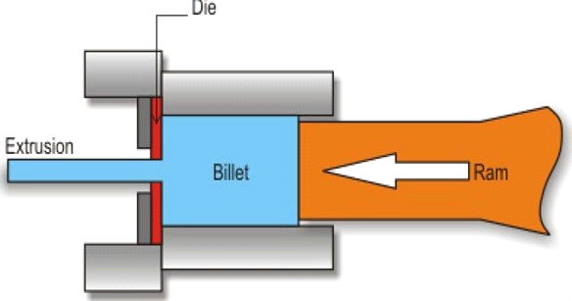

Extrusion Process
In general, extrusion is used to produce cylindrical bars or hollow tubes or for the tarting stock for drawn rod, cold extrusion or forged products.

Most metals are hot extruded due to large amount of forces required in extrusion. Complex shape can be extruded from the more readily extrudable metals such as aluminum.

Similar to forging, lower ram force and a fine grained recrystallised structure are possible in hot extrusion.

However, better surface finish and higher strengths (strain hardened metals) are provided by cold extrusion.

2.1.2 Classification of Extrusion

By Direction: Direct / Indirect extrusion
Forward / backward extrusion

By Operating Temperature: Hot Extrusion
Cold Extrusion
By Equipment: Horizontal Extrusion
Vertical Direction

Direct & Indirect Extrusion

(1) Direct Extrusion:
The metal billet is placed in a container and driven through the die by the ram. The dummy block or pressure plate, is placed at the end of the ram in contact with the billet.
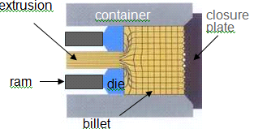

Direct Extrusion

(2) Indirect Extrusion:
The hollow ram containing the die is kept stationary and the container with the billet is caused to move. Friction at the die only (no relative movement at the container wall) requires roughly constant pressure
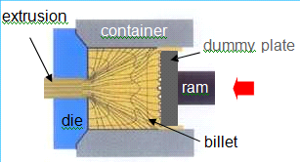

Indirect Extrusion

Forward & Backward Extrusion

(1) Forward Extrusion:
Metal is forced to flow in the same direction as the punch.The punch closely fits the die cavity to prevent backward flow of the material.
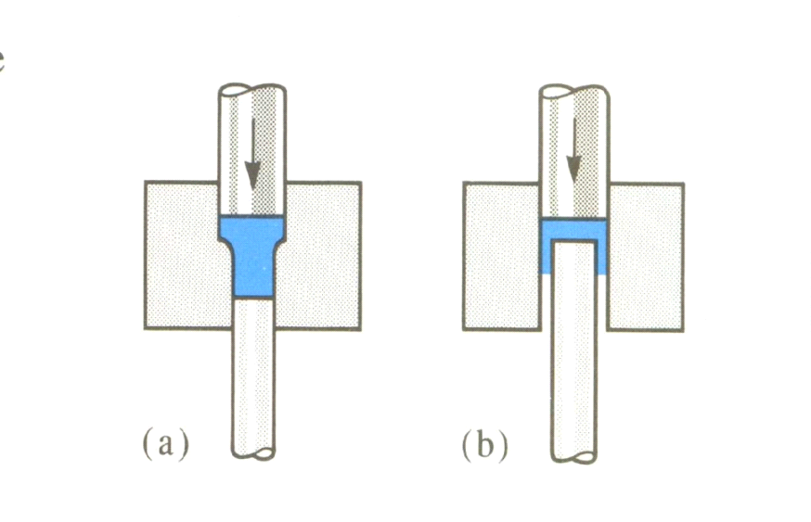

Forward Direction

(2) Backward Extrusion:
Metal is forced to flow in direction opposite to punch movement Metal can also be forced to
flow into recesses in the punch see FIG 3.
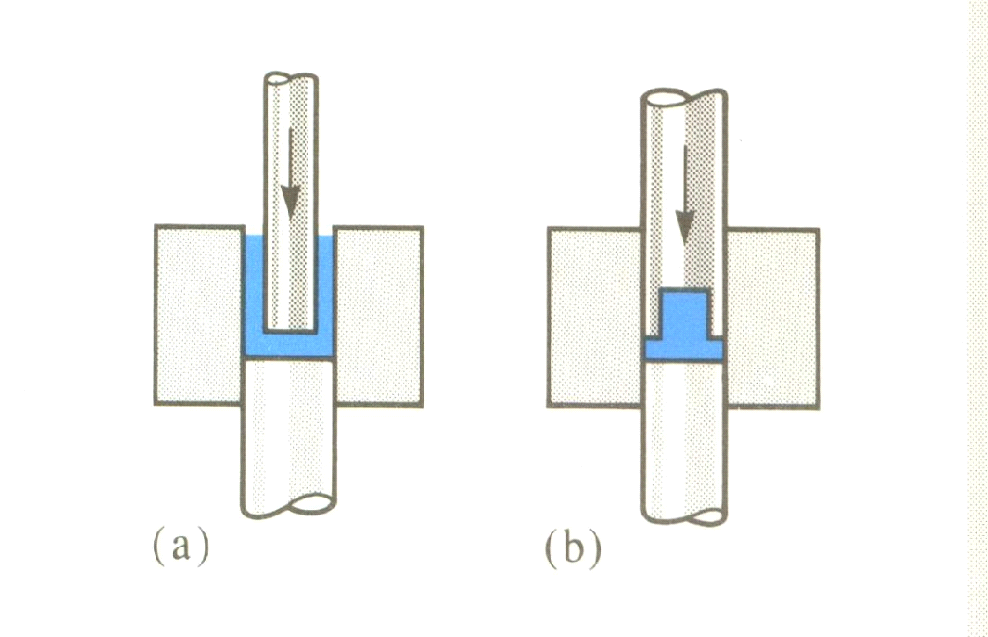

Backward Extrusion

Cold Extrusion
Cold Extrusion is the process done at room temperature or slightly elevated temperatures. This process can be used for most materials-subjected to designing the robust enough tooling that can withstand the stresses by extrusion.
Examples of the metals that can be extruded are lead, tin, aluminium, alloys, copper, titanium, molybdenum etc.
Materials that are commonly cold extruded include: lead, tin, aluminum,copper, zirconium, titanium, molybdenum, beryllium, vanadium,niobium, and steel

Advantages
-No oxidation takes place.
-Good mechanical properties due to severe cold working as long as the temperature created are below the recrystallization temperature.
-Good surface finish with the use of proper lubricants.

Hot Extrusion
Hot extrusion is done at fairly high temperatures approximately 50 to 75 % of the melting point of the metal. The pressures can range from 35-700 MPa.

Most hot extrusions are done on horizontal hydraulic presses that range from 230 to 11,000 metric tons (250 to 12,000 short tons).
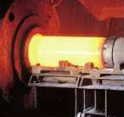

Hot Extrusion

Due to high temperatures and pressures and its detrimental effect on the die life as well as other components, good lubricants is necessary. The biggest disadvantage of this process is its cost for machinery and its upkeep.

Extrusion Equipments

(1) Presses
-Horizontal Presses
-Vertical Presses

(2) Extrusion Dies
-Die Design, Die Material

(3) Tools
-Typical arrangement of extrusion tools

Horizontal Extrusion Process

Used for most commercial extrusion of bars and shapes.

Disadvantages:
-deformation is non-uniform due to different temperatures between top and bottom parts of the billet.

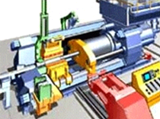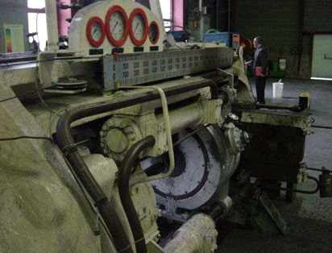

Horizontal Extrusion Process

Vertical Extrusion Presses

Chiefly used in the production of thin-wall tubing.

Advantages:
-Easier alignment between the press ram and tools.
-Higher rate of production.
-Require less floor space than horizontal presses.
-uniform deformation, due to uniform cooling of the billet in the container.

Requirements:
-Need considerable headroom to make extrusions of appreciable length.
-A floor pit is necessary.
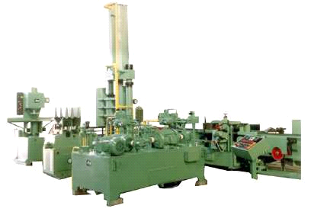

Vertical Extrusion Machine

2.1.3 Advantages And Disadvantages of Extrusion

Advantages
-Continuous
-High production volumes
-Low cost per pound
-Efficient melting
-Many types of raw materials
-Good mixing (compounding)

Disadvantages
-Limited complexity of parts
-Uniform cross-sectional shape only

2.1.4 Application:
-Casing and column pipes for bore well
-City sewage Pipes
-Shopping bags, Grocery bags, T-shirt bags ect.
-Liners & lamination film for aluminium foil, jute paper and board
-Liner for woven sacks, Cans and other industrial needs
-Refuse bags, diaper films, packaging of diary products
-Green house films, packaging of frozen foods
-Tea packaging
-Rice packaging

2.1.5 Types of Extrusion Machines:
-Pipe Extrusion Lines
-blown Film Lines
-Blow Moulding Machines

CHAPTER 2

PIPE EXTRUSION LINES MACHINES

2.2.1 Introduction
Extrusion is the process where a solid plastic (also called a resin), usually in the form of beads or pellets, is continuously fed to a heated chamber and carried along by a feedscrew within.

The feedscrew is driven via drive/motor and tight speed and torque control is critical to product quality. As it is conveyed it is compressed, melted, and forced out of the chamber at a steady rate through a die. The immediate cooling of the melt results in resolidification of that plastic into a continually drawn piece whose cross section matches the die pattern. This die has been engineered and machined to ensure that the melt flows in a precise desired shape.

Plastics are very common substances for extrusion. Rubber and foodstuffs are also quite often processed via extrusion. Occasionally, metals such as aluminum are extruded plus trends and new technologies are allowing an ever-widening variety of materials and composites to be extruded at continually increasing throughput rates. This article will focus only on the extrusion of plastics.

2.2.2 Types of Pipe Extrusion Lines Machines
-Single screw pipe extrusion lines machine
-Twin screw pipe extrusion lines machine

2.2.3 Single Screw Pipe Extrusion Lines Machine

In this machine single screw is used in extruder as shown in fig.
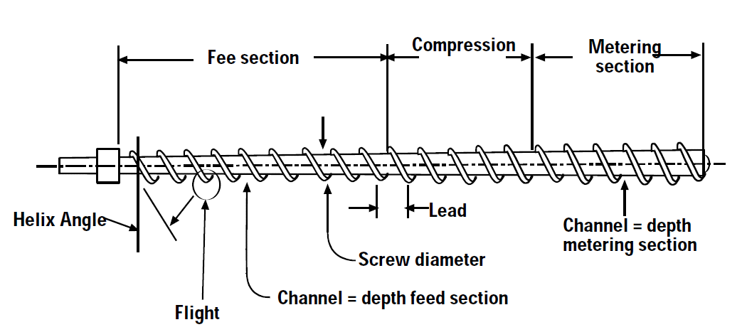
Single Screw Pipe Extrusion Lines Machine
There are three section in feed screw:
(1) Feed Section
(2) Compression Section
(3) Metering Section

Features
-4th generation energy efficient extruder
-European Proven Technology ensures excellent linearity of specific output
-L/D ratio of 37 : 1 ensures excellent melt homogeneity
-“First Time in India, 45 mm Extruder, 330 kgs /hr pipe output”
-Direct coupled design ensures minimum transmission loss
-Wear resistant coating ensures long screw life at high rpm

Raw Material
-PE- Polyethylene
-PPR- Polypropylene
-HDPE- High Density Polyethylene

2.2.4 Twin Screw Extrusion Line Machine
In this machine Twin screw is used in extruder as shown in fig.
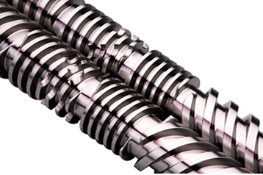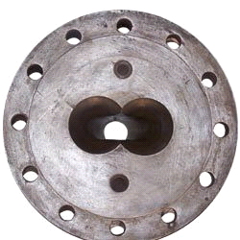
Twin Screw Extrusion Line Machine

Different Types Of Raw Material Used
-PVC - Polyvinyl Chloride
-CPVC - Chlorinated Polyvinyl Chloride

Features
-Minimizes energy inputs
-Achieves uniform pumping
-Front barrel with HSS sleeve offered for selected models
-Minimizes wear & tear
-Economic replacement option
-High accuracy of ±1 C
-Hard face coating on selected models

Application
-Supplying potable water for rural and urban places
-Casing and column pipes for bore well
-City sewage Pipes
-Domestic plumbing
-Effluent discharge lines
-Electrical conduits
-Sprinkler irrigation system
-Inside housing telecom connections

2.2.5 Working of Extrusion Line Machine
In basic extruder machine Plastic pellets or beads(also referred to as resin) are fed from the hopper along a feed screw through a barrel chamber.

As the resin travels along the barrel, it is subject to friction, compression, and heated zones. The result is that the resin melts and further travel at the exit end of the screw serves to mix the melt homogeneously. The melt enters a chamber designed to ensure an evenly distributed flow to the die. In many machines, a melt pump is used to prevent any pressure surges.

Also, breaker plates serve to prevent any solid particles or foreign objects from passing through the die, then it passes from the vacuum unit where it cool down and get proper shape and it prevents bending of pipe and then it goes to traction unit it pull to cutting unit where pipe is cut down as per required length.

2.2.6Components of E.L.M.

Extruder
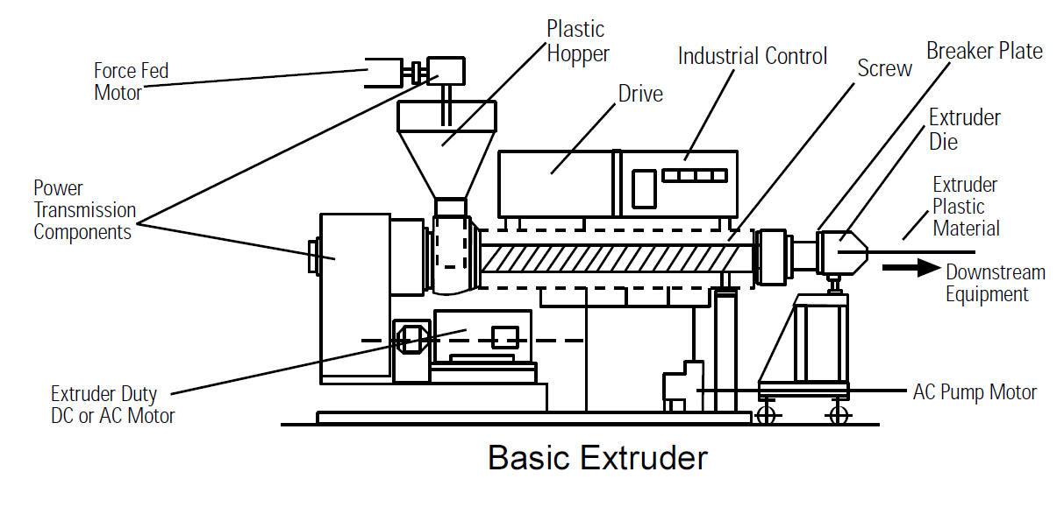

Extruder
In The Extruder Raw material is Feed through hopper in barrel and goes to feed screw which is driven by the external device like motor and it forward the material .During travelling the material it is heated by the heater at required temperature for melting purpose then this melt material pumped to the die.

Parts Of Extruder

Feedscrew
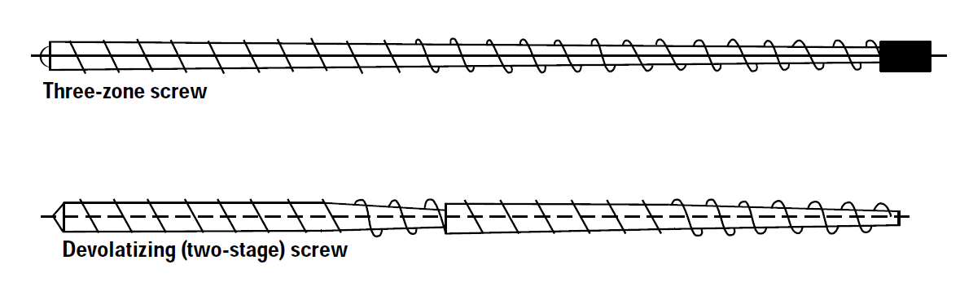

Feed Screw

As the only moving part in many extruders, feed-screws must do the job of moving the resins through the barrel chamber in a steady and predictable manner. As a result, and the feed-screw is critical to the design.

Die and Die Head
Dies can take on a variety of shapes and have adjustable openings. In the case of filament extrusion and others, multiple duplicate die patterns to extrude many strands in parallel can be found on a single die.

Dies are designed to compensate for effects of shrinkage when a melt re-solidifies, two dimensioned size adjustments, and varying rates of solidification. Dies must be free from defects and scratches, otherwise the melt could show the defect's pattern.
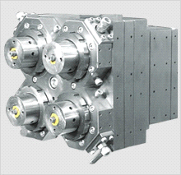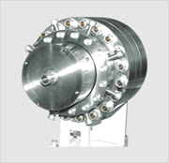
(a) Multiple die head (b) Single die head

Die and Die Head

Barrel chamber

The barrel also is heated to facilitate melting of the resin. Although the major contributor to melting is friction, the heat as conducted through the barrel can serve as a "fine adjust" or vernier in temperature control and energy input. Electrical resistance heating is a common method employed.

This thick-walled steel chamber that is expected to withstand high pressures (~ 20,000 psig), is precisely machined for a tight fit with the feedscrew, and has a hardened steel alloy on its inside wall to prevent wear and corrosion. Some barrels will also have a grooved feed zone to increase the frictional forces on the resin.

Cooling Unit
-Intensive cooling provided to ensure high production ratio
-Easy cleaning bayonet type spray nozzle provided
-Accurate vacuum control, water level & temperature control provided
-Additional vacuum chamber and axial movement provided from VST-250 and above for quick startup and less wastage
-Manual slide rail arrangement for Axial transverse movement of the tank
-Dual vacuum spray tanks on common frame for dual pipe extrusion line
-Imported filters for online cleaning
-Air operated solenoid values optionally
-Cyclone separator for vacuum pump
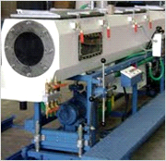

Cooling Unit

Traction Unit
-Up to 6 belt tracting device to suit pipe diameters
-Different line speeds can be changed through change of sprockets
-Track adjustment by pneumatic control
-Self adjustment track suspension provided
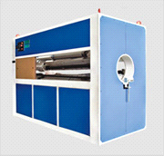

Traction Unit (www.windsormachines.com)
-Counter balance pressure to balance track weight for thin pipes offered
-Encoder for length measurement & feed back arrangement offered optionally
-Easy accessibility for maintenance of all components
-Dual twin-track traction units for dual pipe extrusion line

Cutting unit
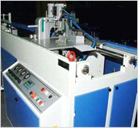

Cutting Unit (www.windsormachines.com)
-Carbide tipped rotating circular saw for longer life
-Pneumatically operated carriage movement
-Clamping force adjustable depending upon the wall-thickness of the pipe
-Swarf removal system optionally offered
-Trolley movement on linear motion bearings
-Special guillotine designed cutter for PPR pipes
-Dual cutter for dual pipe extrusion line

Planetary Cutting Unit (PCU)
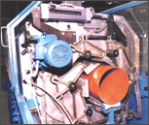

Planetary Cutting Unit (PCU)

Salient Feature
-Mechanical actuator instead of hydraulic or pneumatic
-6 Jaw universal clamping
-On line chamfering provided
-Chamfering without replace ring
-Direct Gear drive for rotating drum
-Compact Swarf extraction system
-Power supply through slip ring – No moving cables
-Battery back-up for auto saw with drawl

2.3 BLOW MOULDING MACHINE

2.3.1 Introduction
Blow molding (also known as blow moulding or blow forming) is a manufacturing process by which hollow plastic parts are formed. In general, there are three main types of blow molding: extrusion blow molding, injection blow molding, and stretch blow molding.

The blow molding process begins with melting down the plastic and forming it into a parison or preform. The parison is a tube-like piece of plastic with a hole in one end in which compressed air can pass through.

The parison is then clamped into a mold and air is pumped into it. The air pressure then pushes the plastic out to match the mold. Once the plastic has cooled and hardened the mold opens up and the part is ejected.

2.3.2 Features of Blow Moulding Machine
-Robust design
-Faster dry cycle speed
-Forward - reverse movement on rails for ease of mould loading
-Sturdy contraction
-No vibrations even at high speed
-Extruder up-down movement [Motorised]
-Fixed height extruded in KBM 100 with up-down movement of mould clamping unit
-Above given features minimize flash and hence wastage
-A.C. motor with variable speed A.C. drive for extruder
-Helical gear box with built in thrust for efficient speed reduction
-Accumulator die head of FIFO design
-Faster colour change
-Minimized wastage
-On-off type four point hydraulic parison thickness control
-Optimally designed hydraulic power pack ensures minimum power consumption

2.3.3 Application of Blow Moulding Machine
-Edible oil packaging
-Lubricants packaging
-Packaging of drinking water
-Pharmaceuticals packaging
-Chemicals packaging
-Pesticides and insecticides packaging
-Automobile components
-Toys

2.3.4 Working of Blow Moulding Machine
Extrusion blow molding is the most widely used technique.

The principle of the extrusion blow molding process is that a parison, which is formed by continuous extrusion of material and rotating of the screw in the barrel, is clamped between two halves of a mold, cut-off and inflated with air to fill the mold. The mold is cooled so that the product is frozen into the mold shape, while still under air pressure. The mold is then opened and the part removed.

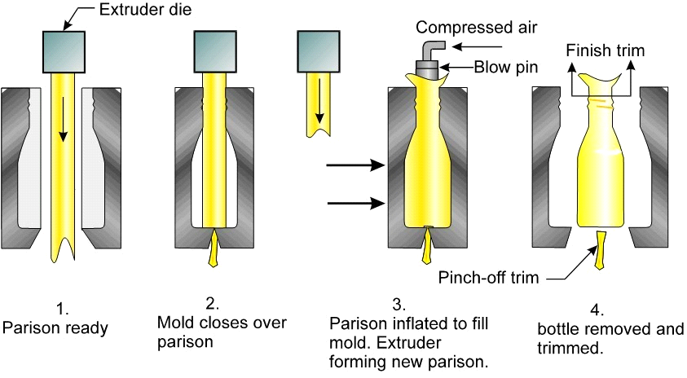

Blow Moulding Machine

2.3.5 Components of Blow Moulding Machine

Extruder
In The Extruder Raw material is Feed through hopper in barrel and goes to feed screw which is driven by the external device like motor and it forward the material.
During travelling the material it is heated by the heater at required temperature for melting purpose then this melt material pumped to the die.

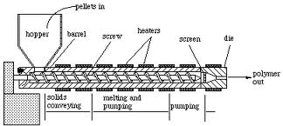

Extruder

Accumulator Head

Reasons for Development of Accumulator Head
-The desire to mold even larger parts
-The need to extrude parison quickly to minimize hang time and parsonage
-Issues with parison knit line
-Strength
-Appearance
-More difficult to process high molecular weight polyethylene and form a good parison
-Circumferential wall thickness distribution
-The head can be fed polymer continuously
-Capable of fast parison extrusion rate

Working
“accumulator head”, which acts like a reservoir and push-out piston, it is possible to accumulate enough resin inside the head for one part so that the part “shot” can be pushed out quite rapidly immediately before the mould closes round it to start the moulding cycle.
The extruder screw can be stopped and started as required to fill the accumulator in time for the next push-out and moulding operation. The accumulator head machine, as well as helping to minimize the effects of parison stretching in long parts, can also be useful for moulding semi-crystalline engineering resins when rapid cooling or oxidization of the parison surface may cause problems when those materials are moulded in continuous extrusion machines.

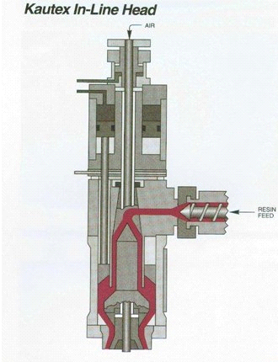

Accumulator Head

Die
The parison which comes out from the accumulator is entered into the die. This die is compressed by hydraulic unit so the parison between dir is also compressed and get the shape of die.
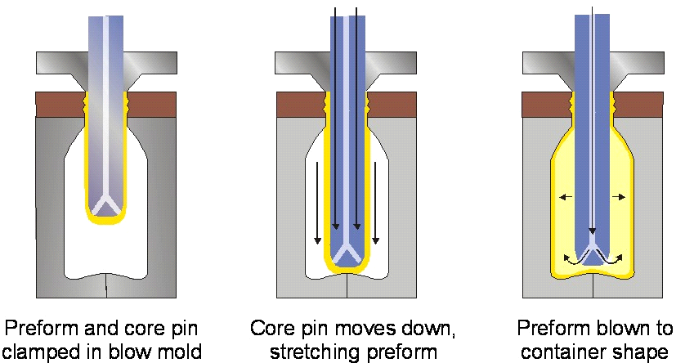

Die

Parison Cutter
The knife blade is operated by pneumatic cylinder through a rack and pinion arrangement. The possession of knife blade with respect to die ring is adjustable. The knife move to left to right in one cycle and right to left in next cycle.

Hydraulic unit
Almost every moving part in a blow molding machine depends upon the hydraulic system, which uses oil as a working fluid to supply the force that enables the parts to move.

Figure shows schematically the principal parts of a hydraulic system.

Hydraulic oil is stored in an open reservoir tank (1).

Every time the oil is withdrawn from the tank, it passes through a filter (2) containing a pack of fine mesh screens and usually a magnet. The screens remove any particles of dirt or other foreign matter and the magnet grabs any tramp iron that may get into the system.

A hydraulic pump draws oil from the tank and moves it to the points of use. Pressure in the system is indicated by a pressure gauge (4).

Because the hydraulic pump runs constantly, but the demand for the working fluid is intermittent, some method of relieving pressure is necessary. A press relief valve (5) opens and releases oil back to the oil reservoir whenever a specified maximum pressure is sensed.

When the system pressure decreases because of a valve opening and calling for oil, the relief valve instantly closes to maintain the desired pressure level. Oil flowing along the other leg of the branch moves through a check valve (6). This valve permits flow from right to left. The flow of oil branches again, with one path leading to an accumulator (7). This is a storage device internally equipped with a piston or flexible bladder. The main purpose of the accumulator is to supplement flow from the pump when a large volume of oil is required within a short time interval.

A hand-operated valve (8) is in another leg of the branch so that if a fitting must be disconnected, the oil under pressure in the accumulator can be discharged back to the oil tank instead of at the fitting being opened. Another branch in the oil line leads to a solenoid-piloted, two-positioned, four-way valve (9).

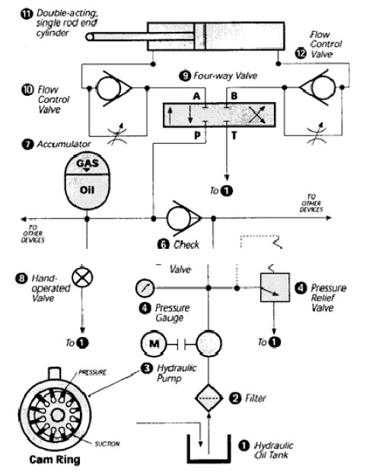

Hydraulic Unit

When the inner position of this valve is shifted to the right, port P is connected to port A and port T is connected to port B. Pressurized oil then passes freely through the flow control valve (10) into the rod end of the double-acting, single-rod, end cylinder (11), forcing the piston to move to the right and expelling oil from the front of the piston at a controlled rate through the flow control valve(12) back to the oil tank.

2.4 BLOWN FILM LINES MACHINES

2.4.1 Introduction
Blown film extrusion is one of the most commonly used thin-gauge fabrication processes in the world. The process of producing film by extruding molten resin into a continuous tube is simple.
A simple blown film line consists of an extruder, die, air ring, iris or bubble cage, collapsing frame, and a winder.

2.4.2 Types of Blown Film Lines Machines
- Monolayer Blown Film Lines Machine
-Three layer Blown Film Lines Machine
-Five layer Blown Film Lines Machine

2.4.3 Monolayer Blown Film Lines Machine

Introduction
Monolayer Blown Film Lines Machine is one type of Blown Film Line machine which is used to produce a one layer film.
One layer film generally used for packing purpose but it consist only one layer so it can’t be used for packing a costly material.
Monolayer Blown Film Lines Machine consist only one Extruder and one type of raw material to produce a Mono layer film.

Different Raw Material Used
-LDPE- Low Density Polyethylene
-LLDPE- Linear Low Density Polyethylene
-HDPE- High Density Polyethylene

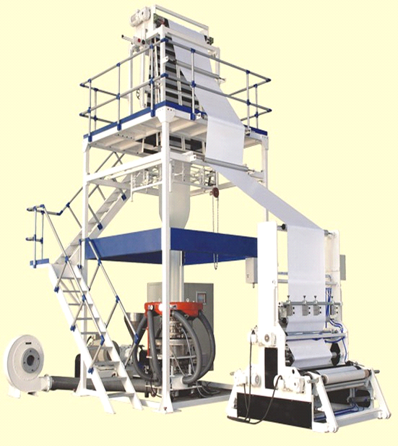

Monolayer Blown Film Line Machine

Application
-Shopping bags, Grocery bags, T-shirt bags ect.
-Liners & lamination film for aluminum foil, jute paper and board
-Liner for woven sacks, Cans and other industrial needs

2.4.4 Three layer Blown Film Lines Machine

Introduction
Three layer Blown Film Lines Machine is one type of Blown Film Line machine which is used to produce a Three layer film.
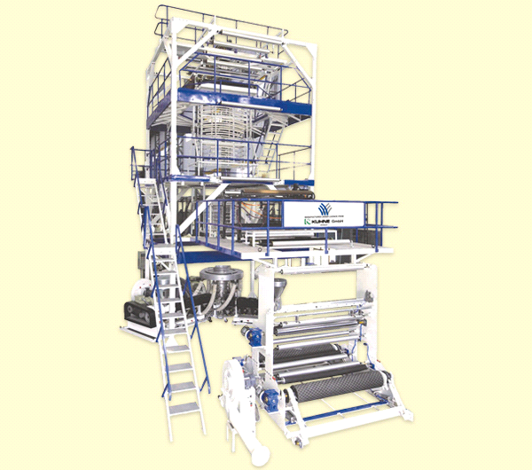

Three layer Blown Film Lines Machine

Different Raw Material Used
-LDPE- Low Density Polyethylene
-LLDPE- Linear Low Density Polyethylene
-HDPE- High Density Polyethylene
-Nylon

Application
-Milk film
-Rice packaging
-Tomato catch up packaging
-Liquid packaging

2.4.5 Five layer Blown Film Lines Machine

Introduction
A five layer Blown Film Lines Machine consist five Extruder and five type of raw material to produce a five layer film.
Five layer Blown Film Lines Machine is one type of Blown Film Line machine which is used to produce a five layer film. One layer film generally used for packing purpose but it consist only five layer so it can be used for packing a costly material.

Different Raw Material Used
-LDPE- Low Density Polyethylene
-LLDPE- Linear Low Density Polyethylene
-HDPE- High Density Polyethylene
-NYLON
-MLLDPE- Metallocene Linear Low Density Polyethylene

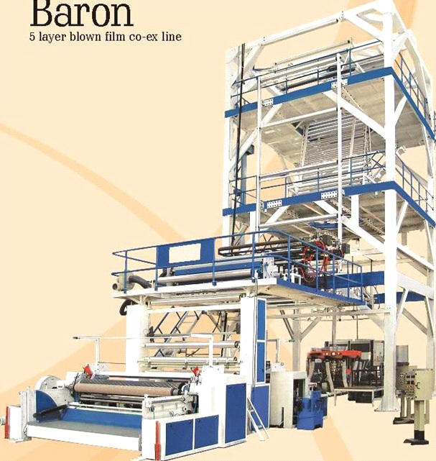

Five layer Blown Film Lines Machine

Application
Frozen meat and fish packaging
Edible oil packaging
Coffee packaging
Almond oil packaging

2.4.6 Working of Blown Film Lines Machine
A typical film blown film machine consists of the following five major units
Extruder unit—converts the solid pellets into hot melt.
Die unit—forms the hot melt into tube.
Cooling unit—cools down and solidifies the hot melt.
Take-off unit—pulls and flattens the tube at constant speed.
Winding unit—winds-up the flattened tube into finish rolls
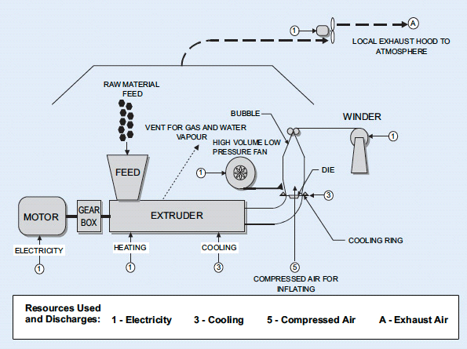

Working of Blown Film Lines Machine
Blown films are created by feeding plastics pellets into an extruder where they are melted and homogenized before they are pumped through a circular blown film die.

The melted plastics form a continuous tube which is drawn from the die. It is inflated and simultaneously cooled by rapidly moving air.

The tube, also called a “bubble,” is then flattened as it passes the collapsing frames and drawn through nip rolls and over idler rolls to a winder which pulls and winds the finished rolls of film.

2.4.7 Components of Blown Film Lines Machine

Extruder
In The Extruder Raw material is Feed through hopper in barrel and goes to feed screw which is driven by the external device like motor and it forward the material .
During traveling the material it is heated by the heater at required temperature for melting purpose then this melt material pumped to the die.
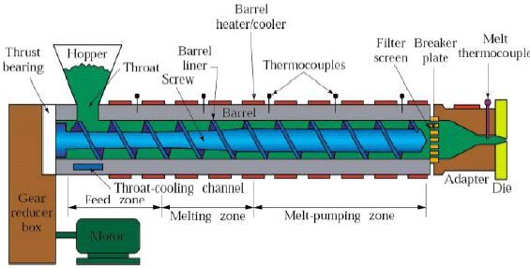

Extruder

Air Cooling Rings
Blown film air rings are used primarily to stabilize the bubble and secondarily to cool the melt. In plastics forming, a circular manifold distributes an even flow of cool air into a hollow tubular form passing through the manifold.
An air ring is installed just above the die in an upward air cooling blown film machine. The air outlet called a lip (or slit) has an annular shape that surrounds the molten resin extruded from the die. Air is introduced into the ring by the blower, and the air is turned into a uniform flow inside the air ring. Then the air is blown through the lip against the molten resin for cooling.

If the flow of air blown out of the lip is not uniform, it leads to non uniform cooling. As a result, film thickness will be uneven. To prevent this, the air ring is designed to ensure uniform air flow over the entire lip. As the molten resin is cooled, it becomes “frosty,” or less clear (transparent), and a solidification border appears. This borderline is called a frost line.

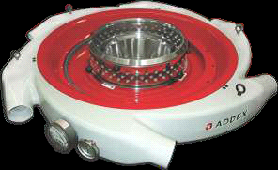

Air Cooling Ring

Die Unit
Use: Die is used to produce required dimensional bubble.

Feature:
-Universal spiral mandrel die designs
-Stream lined flow path to ensure faster change over
-CNC machining to ensure highest precision
-All flow surfaces mirror polished to eliminate
-degradation of plastic melt
-A Unique designed flow path to achieve differential
-Low profile die design with spiral mandrel, easy assembly and cleaning
-Single to dual melt channel distribution
-Fully open die center, maximize Internal Bubble Cooling(IBC) cooling capacity
-Strong self-cleaning, shortest purging time
-No port lines, no layer leakage
-Low pressure drop

Calibration Baskets-Options

Use: it used to calibrate the bubble dimensional

Feature
-Standard cage for Duke lines
-9 point contact type motorized cage for IBC standard lines
-Scissor design multipoint contact cage
-Universal spiral mandrel die designs
-Stream lined flow path to ensure faster change over
-CNC machining to ensure highest precision
-All flow surfaces mirror polished to eliminate degradation of plastic melt
-A Unique designed flow path to achieve differential layer ratio effectively
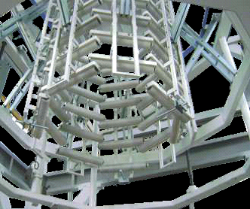

Calibration Baskets

Take Off Assembly

Use: it used to take off the bubble to haul off unit.

Reversing Haul Off
-For all standard lines, reversing haul off forms am integral method for gauge randomization
-Horizontally designed take off available up to 3000 mm roller width
-Variable frequency A.C. drive for nip
-Synchronized drives
-Water cooled nips(Optional)

Features
-Rigid structure & longer support guides the bubbles at higher output & line speed
-Operator friendly frame setting
-PBT bushes as standard
-Option of Aluminum rollers available for specific application
-Option of motorized adjustment of slats
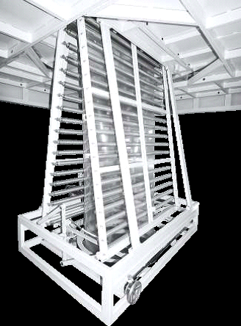

Take Off Assembly

Haul Off Unit
Use: it used to control the gauge variation of film.

Features
-For all standard lines, reversing haul off forms an integral method for gauge randomization
-Horizontally designed take off available up to 3000mm roller width
-Variable frequency A.C. drive for nip
-Synchronized drives
-Water cooled nips (optional)
-Slewing ring design

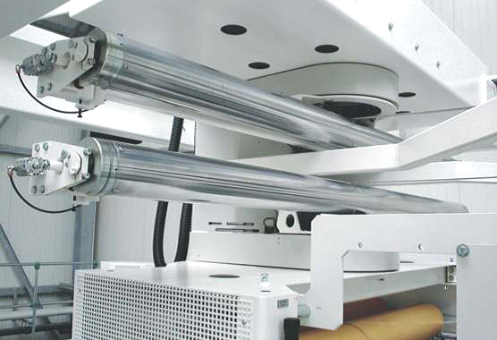

Haul Off Unit

Film Winders

Use: it used to wind the produced film.

Fully automatic winder
-Winding capacity - 1000 mm /1000 Kg
-Line speed – Max. 150 m/min
-Automatic reel change over and automatic web cross-cutting mechanism
-Pneumatic Shaft (4 No’s)
-Expander roller - Polyband /Banana
-European gear drives
-Load cell for tension control
-Vector flux drive in closed loop
-Hydraulic lowering of wound roll

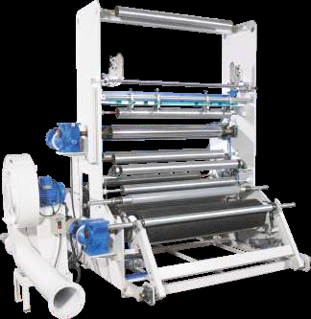

Winders

SEMI AUTOMATIC WINDERS
-Two station semiautomatic surface winders.
-Online reel changeover without any wastage
-Bow roller provided as expander roller
-Option of Auto-tension control
-Ultra sonic sensors for IBC control
-Gravimetric dozing or batch blending with yield control
-Fully automatic thickness and measurement

CHAPTER 3

PROBLEM SUMMARY

3.1Pipe Plant Machine:
There are some reasons of output failure in Pipe Plant Machine, which are explained below.
- Improper wall thickness
- Inside rough surface
- Brittle pipes

3.1.1 Improper wall thickness
~ when the thickness of output pipe’s are somewhere is thin or somewhere is thick it’s call improper wall thickness

3.1.2 Inside rough surface
~ when the inside surface of pipe is rough and improper
3.1.3 Brittle pipes
~ when the pipe is broken on low pressure is cold is brittle pipe

3.2 Blown Film Line Machine
There are some reasons of output failure in Blown Film Line Machine, which are explained below.
- Over-heating motor
- Gauge variation (transverse)
- Creases of film
3.2.1 Over-heating motor
- Causes
- Insufficient cooling

3.2.2 Gauge variation
- Causes
- Non uniform die gap

3.2.3 Creases of film
- Causes
- Film is over cooled at first nip
- Dirt on rollers tension
- Over or under
- Improper folding & collapsing of bubble

CHAPTER 4

EXPECTED OUTCOME

4.1 SOLUTION OF PIPE PLANT MACHINE

4.1.1 Solution of improper wall thickness

- Align take off equipment
- Adjust rpm of machine and take off equipment
- Profile and rpm of the screw.
- Check heaters on the die

4.1.2 Solution of inside rough surface

- Adjust temp. profile so as to melt polymer completely
- Avoid melt fracture by increasing die temperatures, lowering shear
by reducing screw rpm
- Avoid moisture by pre-drying

4.3.3 Solution of brittle pipe

- Temperatures and adjust rpm of screw (avoiding faster and cold
extrusion)
- Avoid excessive draw down of the pipe
- Avoid using excessive regrind material

4.2 SOLUTION OF BLOW FILM LINE MACHINE

4.2.1 Solution of over heating motor

- Check blower working
- Check direction of blower
- Clean screen at blower inlet
- Make sure blower sucks fresh cool air
4.2.2 Solution of gauge variation

- Adjust die gap
- Clean air ring
- Protect bubble from outside air breeze
4.2.3 Solution of creases of film
- Reduce cooling
- Clean all rollers
- Adjust film tension
- Set slats properly

